Assignment 4-Grouping Results_Breno Jose Gomes de Souza-N01648753

**Part 1: MIN() & MAX()**

A. “What is the lowest price of any item?” No need to provide the item, just

the lowest price.

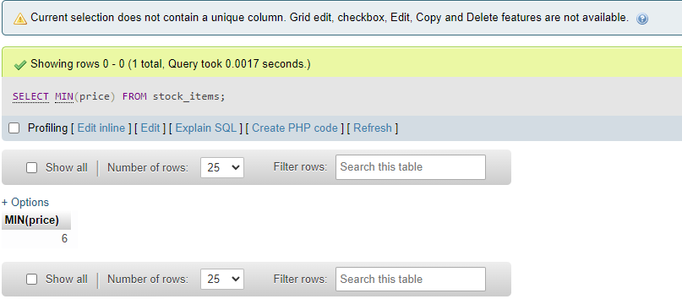

B. “What is the greatest quantity of any item in stock? No need to provide the

item, just the largest quantity.

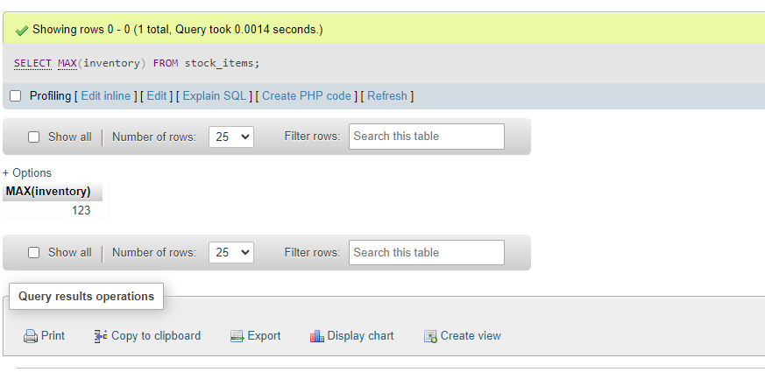

**Part 2: Get Into Groups**

A. Provide a count of employees grouped by role. Include the role and the

count in your results.

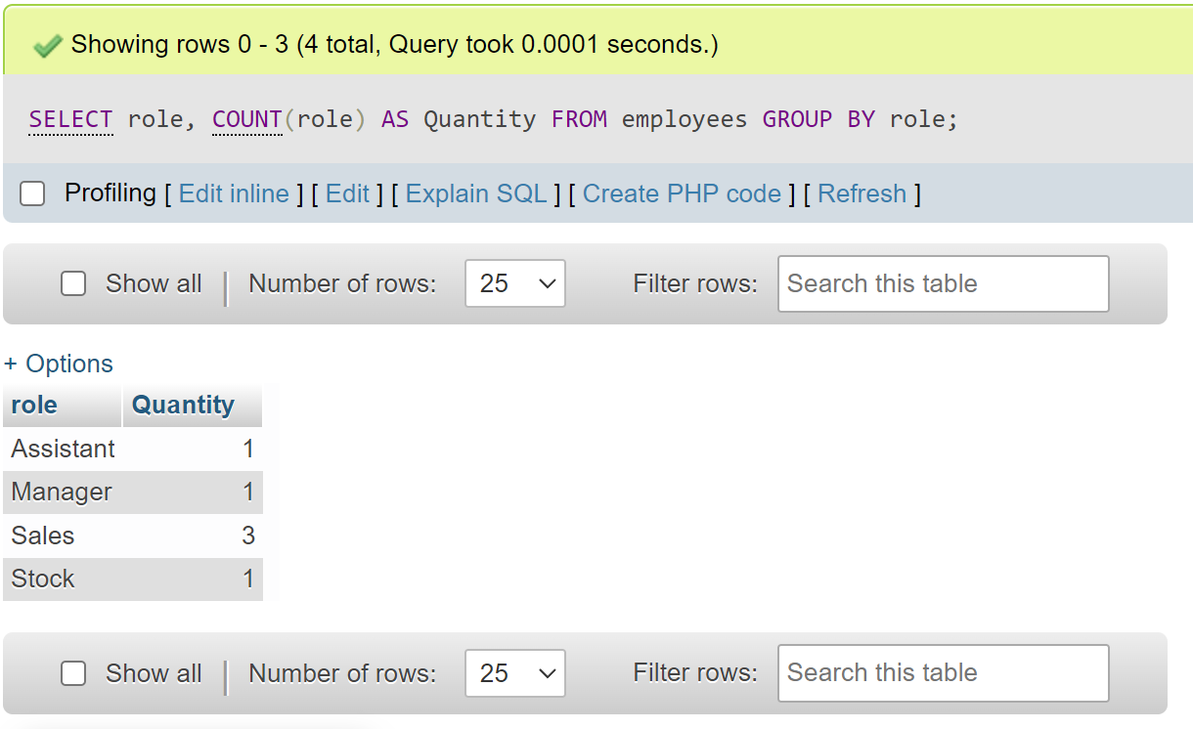

B. Checking for contact info: Create a chart of employees grouped by role that

shows the role, # of employees in that role, and # of phone numbers for

that role.

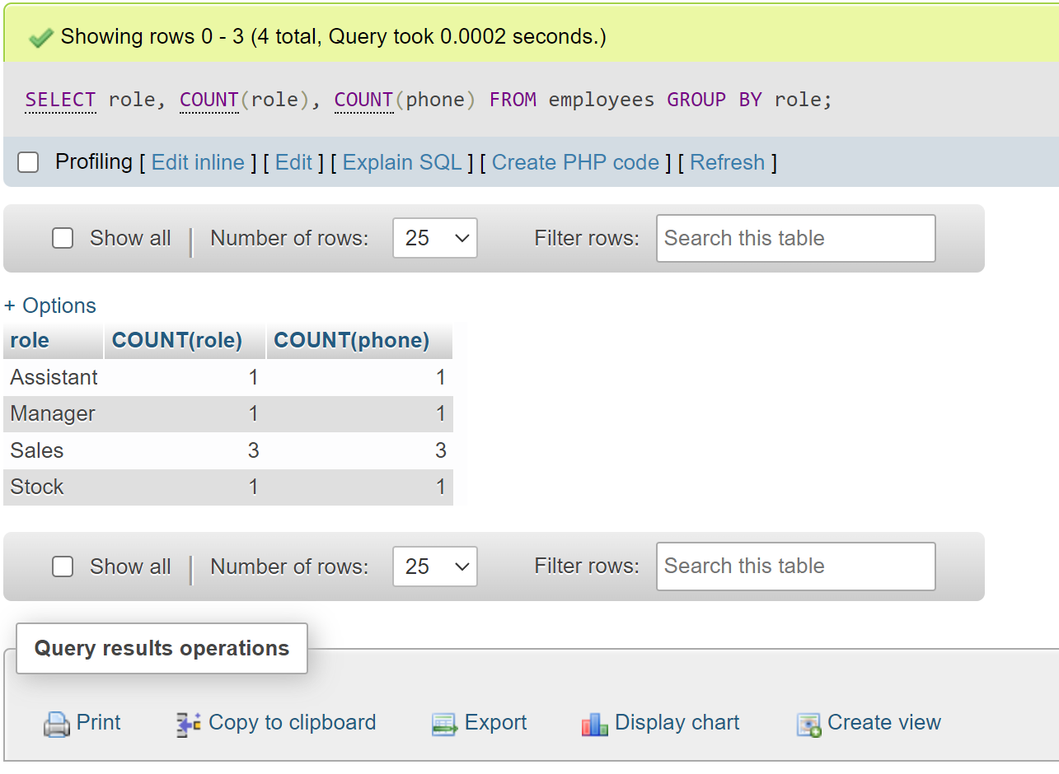

**Part 3: Challenge**

A. Create a count of items by category that excludes the fish category

(“piscine”). Put “Mammals” as the heading for the category.

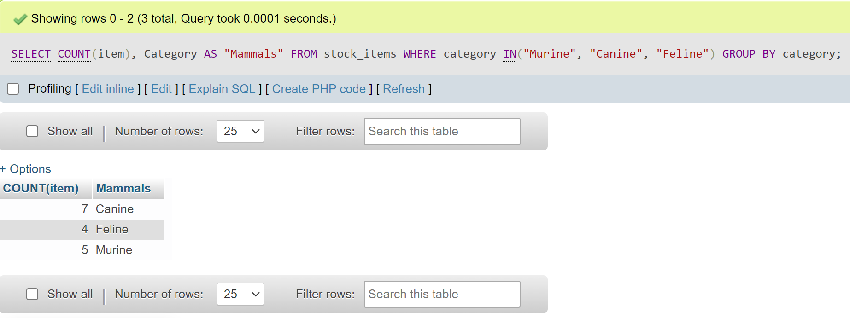

B. Manager: “Inventory time. I need a total of in-stock items by each animal

category, organized by fewest items to the most items. At the top of the

chart I want to see ‘In stock’, and ‘Animal’.”

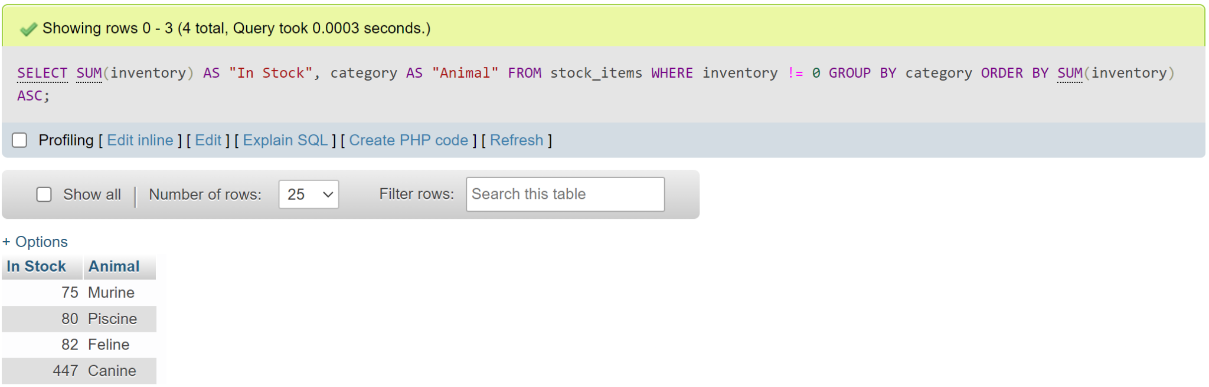

C. Manager: What is the “highest price” from each category organized by the

most expensive to least expensive? The results will show : “Highest price”,

“Category.”

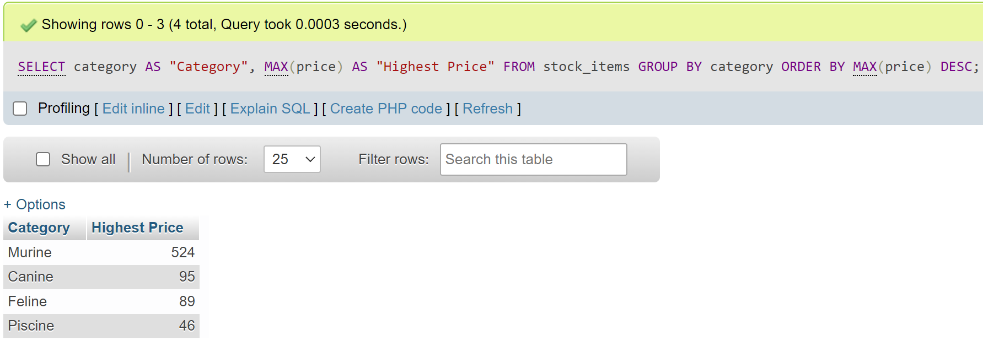

D. Just as you go to the manager’s office with the results from C, the Manager

says, Oh, I need the categories where the highest price is more than $50.

Note: the result set should show “Highest Price”, “Category” at the top.

